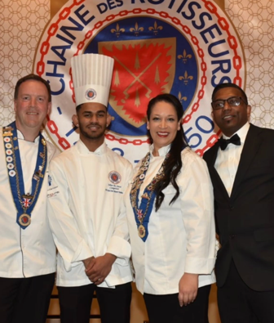
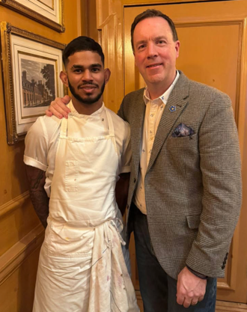

Chef of the Year Competition 2027

National Final: Tuesday 23rd March 2027, University of West London, Ealing

Young Professionals Awards: Friday 30th April 2027, Pan Pacific Hotel, London

International Finals: Wednesday 15th to Sunday 19th September 2027, Paris


The Chaîne des Rôtisseurs Young Chefs Competition (Jeunes Chefs Rôtisseurs) continues to provide one of the most exciting opportunities for young culinary professionals to showcase their talent, creativity and technical skill.

Founded in Switzerland in 1977, the competition has helped identify and support exceptional young chefs, providing a platform to challenge themselves under pressure, gain national recognition and represent their country on the international stage.

The most recent competition held in 2025 saw Johan de Sousa of The Savoy who first competed in 2023, crowned UK Champion before going on to represent Great Britain at the International Finals in Türkiye, where he achieved an outstanding 4th place in the world against some of the finest young chefs from across the globe.

Now it is time to find the next representative for Great Britain.


The competition
Competitors will be challenged to create a three-course (first course, main course and dessert) menu for four guests using a mystery box of ingredients, which remains one of the competition's greatest challenges. Together with selected ingredients from a common table, the competitors have 30 minutes to assess the ingredients and write a menu with only the principal protein revealed 4 weeks in advance. The chefs must rely on their training, instinct and creativity before delivering three exceptional courses under pressure. Chefs are given three and a half hours for preparation, and finished dishes are presented for judging within a 30-minute timeframe.
Dishes are identified by number to ensure complete secrecy and objectivity.

Judging takes place across a range of criteria, including:
- Taste
- Technique
- Presentation
- Balance
- Originality
- Kitchen Organisation
- Cleanliness and Professionalism

The standard continues to rise with every competition, and the experience offers far more than the opportunity to win. Competitors gain valuable exposure, develop confidence, expand their professional networks and test themselves against some of the country's most promising culinary talent.

A candidate for competition at any level must be nominated by their employer, who must be a member in good standing with the Chaîne des Rôtisseurs and be accepted by the Competition Committee. Competitions are held at regional, national and international levels in countries around the world. The competition is open to chefs under the age of 27 years on 1st September 2027.

The competitor applying to enter must:
- Provide a copy of their passport at the time of application
- Provide a short-typewritten profile and/or CV
- be employed full time by a Maître or Chef member in good standing of Chaîne des Rôtisseurs. The Maître or Chef member must be active in their profession and not employed by a judge of the competition
- be available for the dates noted above for the UK finals, the Award Dinner and the International finals

The top three place winners will be announced at the end of the competition and invited to the Young Chefs Award at Pan Pacific Hotel, where the order of the final three will be announced, and the crowning winner will officially start their training for Paris 2027.

All expenses for the competing chef will be paid by Chaîne des Rôtisseurs GB for the international competition.

If you have a talented young chef within your brigade, we strongly encourage you to submit an application to culinaire@chaine.co.uk or your local Bailli and give them the opportunity to take the next step in their culinary journey.

For more information, please go to GB competition and international Competition page.
If your establishment is not at present a member of the Chaine, then please contact either your local Bailli or Bailli Délégué, Philip Evins: bd@chaine.co.uk.

Please return application forms via email culinaire@chaine.co.uk and bd@chaine.co.uk by 18th February 2027.

Kind regards,

Ben Purton, Conseiller Culinaire
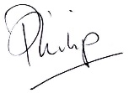 Ben
Philip Evins Ben Purton
Bailli Délégué Conseiller Culinaire

