OMGD Winemakers Dinner
Klein Constantia
Hosted by Matthew Day, Winemaker
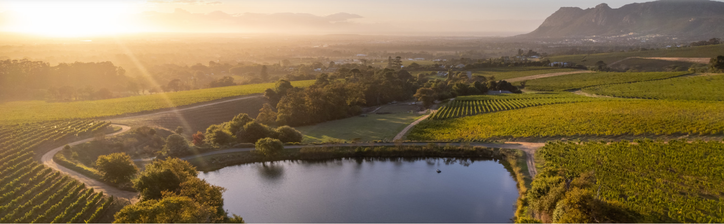
Friday 19 June 2026
GRAND HYATT REGENCY LONDON - THE CHURCHILL
Portman Square, London

Dating back to 1685 and described as one of the world’s most beautiful wine estates, Klein Constantia is set amidst ancient trees on the upper foothills of the Constantiaberg, with views across False Bay.

In 1685, Simon van der Stel, Governor of the Cape, chose the slopes of Constantiaberg for his vision of winemaking excellence. With decomposed granite soils and a cool maritime breeze, the land revealed its potential early — becoming the Cape’s most celebrated vineyard. After van der Stel’s passing in 1712, Constantia was divided. One parcel became Klein Constantia — a name destined to echo through centuries of history.
From the 18th to 19th century, the wines of Constantia captivated the world, cherished by Napoleon, celebrated by Jane Austen, and served in royal courts across Europe.
Revived in 1990, Vin de Constance once again took its place among the world’s most revered wines.
Since 2011, Klein Constantia has entered a new era under the stewardship of Zdenek Bakala and Charles Harman, joined by Bordeaux legends Hubert de Boüard and Bruno Prats. Together, they have brought international expertise and a renewed commitment to excellence.
Today, winemaker Matthew Day and viticulturist Craig Harris guide the estate with precision and respect for the land. Klein Constantia stands as one of the Cape’s most celebrated fine wine estates, where heritage and innovation continue to meet, and the story of Vin de Constance inspires the world anew.
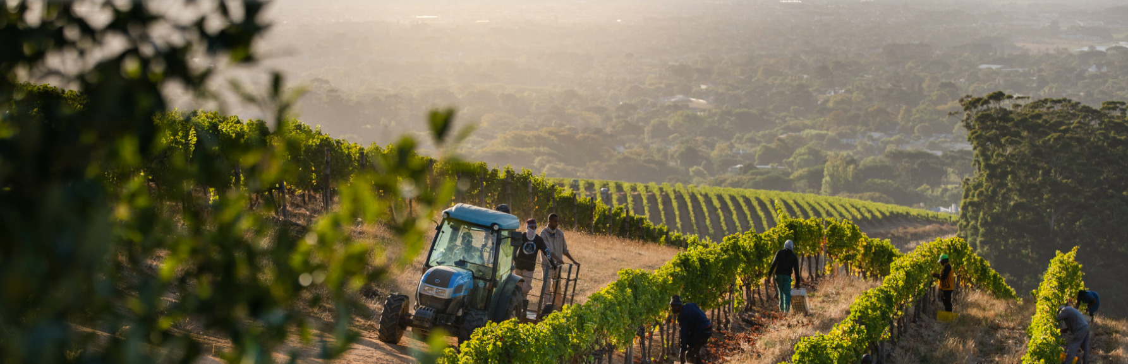

Below you will see the fabulous line up of 8 wines making this a must for all wine lovers.
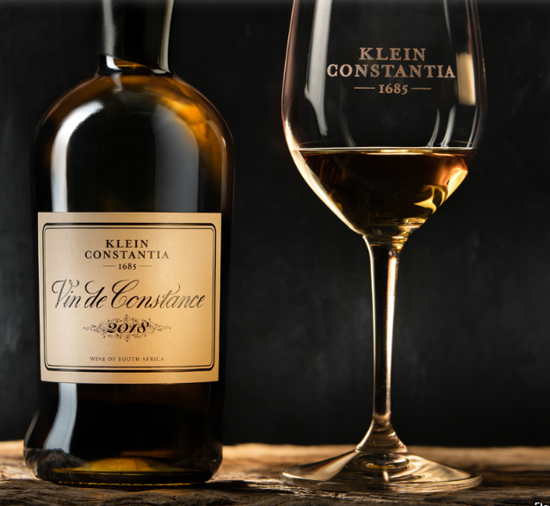

Priority booking will be given to OMGD members.
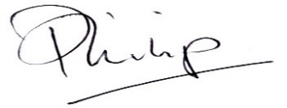
Philip Evins
Bailli Délégué
Membre du Conseil Magistral
Reception

Klein Constantia Cap Classique Blanc de Blanc 2021 Chefs Canapes selection

Dinner

Whipped Feta, Tender vegetables, Candied walnuts, molasses Klein Constantia Estate Sauvignon Blanc 2024 & Clara Sauvignon Blanc 2021

*****
Seared Red Tuna, Green Apple, Finger Lime, Potato Gauffrettes
Klein Constantia Rietbos Chardonnay 2024

*****
Herb Crusted Lamb Rump, Braised Lamb Leg Croquette, Potato Fondant, Spring Greens, Rosemary Jus
Anwilka 2019 & Estate Red 2018 en Magnum

*****
Apricot and Almond Tart, Honey Parfait, Candid Citrus
Vin De Constance 2022 & Vin De Constance 2016

*****

Tea, coffee and petit fours

Dress: Business suits and Cocktail dresses with Chaîne ribbons

