Sussex Bailliage 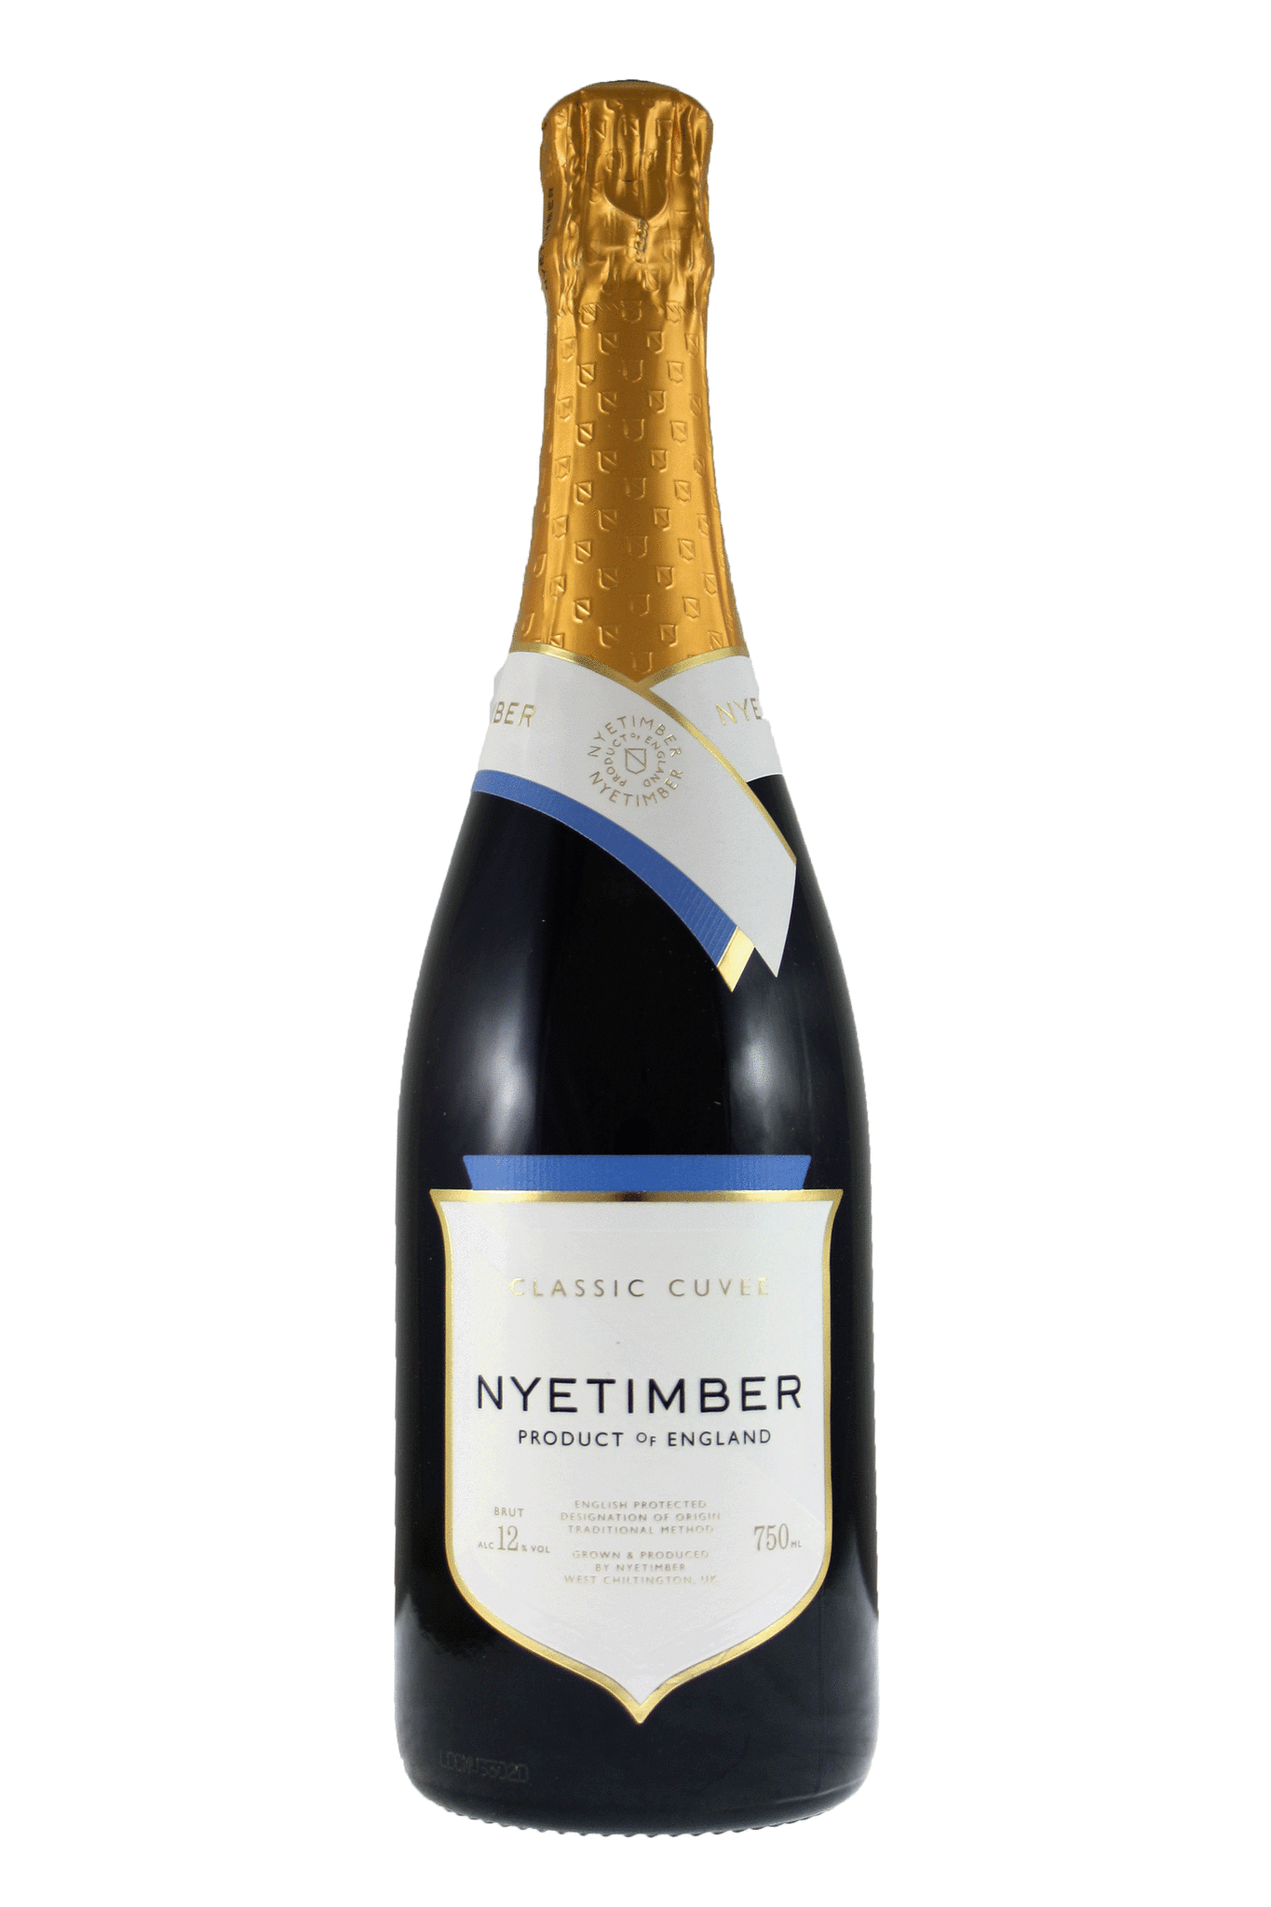

Gravetye Manor

Taste of Summer Dinner
Gravetye Manor, Vowels Lane, West Hoathly, Sussex, RH19 4LJ
Saturday 30th July 2022
Dress: Smart, Chaîne Regalia
Booking Form £150 per person inc. wines
See over for full menu and details
Names | Amount  £ | Dietary requirements (please state any)
 | 150
Total:
Please return by email to: dominic.buckwell@gmail.com

Payment directly to Gravetye: contact Eleanor@gravetyemanor.co.uk Telephone: 01342 810567

Sussex Châine de Rôtisseur at Gravetye Manor
“A taste of Summer Dinner” - Saturday 30th July 2022

7pm Arrival for a stroll in the Gardens
7.30pm English Sparkling Wine Reception courtesy of Nyetimber
8.30pm Three Course Dinner

Menu below is illustrative only and based on the 2021 July menu. Final details will be available in June and choices will be required in early July. There will also be canapés and pre-starter chosen by the chef to compliment, and coffee or tea with petits four to finish. Alternatives available to meet any dietary requirements.

Gravetye Garden Salad
young vegetables, confit yolk, herbs & flowers

Marinated Heritage Tomatoes
white peach, goats cheese mousse, gremolata & basil

Gravetye Smoked Salmon Pressing
beetroot, watercress, salmon roe & crème fraîche

Carpaccio of Aged Sussex Beef Fillet
pickled girolles, preserved lemon & wholegrain mustard

(Domaine Albert Bichot, Corton-Charlemagne Grand Cru Domaine du Pavillon 2014)

- oOo -

Newhaven Turbot
courgette, white beans and an elderflower sauce

Roasted Guinea Fowl
wilted lettuce, broad beans and mead

Romney Salt Marsh Lamb Fillet
braised shoulder, garden brassicas, mashed potato & minted jus

Seared Sweetheart Cabbage
cep mushroom, baby leek, pak choi & black truffle

(Château Moulin Riche, St Julien, Bordeaux 2015)

To Finish

Raspberry Soufflé
clotted cream ice cream

Lemon Verbena Posset
redcurrant sorbet, almond crisps & sumac meringue

Guanaja Dark Chocolate Bar
coffee, cocoa nibs & sea salt

Five Sussex Artisan Cheeses with Accompaniments
Flower Marie, Golden Cross, Sussex Charmer, Burwash Rose & Brighton Blue

(Château Climens, Barsac Bordeaux 2005)

11pm – Carriages

Payment (£150 per person) directly to Gravetye Manor upon booking:
Account Name : Saphos Hotels LLP
SORT Code : 40-04-09
A/c. No. : 81872516
Reference : your full name
Please check with dominic.buckwell@gmail.com if places are available before paying by bank transfer.
Rooms available (minimum two night stay) on request: https://www.gravetyemanor.co.uk/

